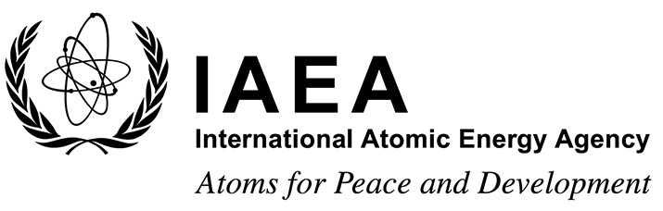 |  | Form B  EVT2100681
Form for Submission of a Paper
Tenth International Symposium on Naturally Occurring Radioactive Material (NORM X)

Utrecht, the Netherlands
9 to 13 May 2022
To be completed by the participant and sent to the competent national authority (e.g. Ministry of Foreign Affairs, Permanent Mission to the IAEA, or National Atomic Energy Authority) of his/her country for subsequent transmission to the International Atomic Energy Agency (IAEA) either by email to: Official.Mail@iaea.org or by fax to: +43 1 26007 (no hard copies needed). Please also send a copy by email to the Scientific Secretary H.B.Okyar@iaea.org and to the Administrative Secretary s.elias@iaea.org.
Participants who are members of an invited organization can submit this form to their organization for subsequent transmission to the IAEA.

Deadline for receipt by IAEA through official channels: 1 April 2022
Title of the paper:
Family name(s) and first name(s) of all author(s):  e.g. Smith, John | Scientific establishment(s) in which the work has been carried out |  |  | City/Country
1.
2.
3.
Family name and first name(s) of author presenting the paper: e.g. Smith, John |  |  | Mr/Ms:
Mailing address:
Tel. (Fax):

Email:

I hereby agree to assign to the International Atomic Energy Agency (IAEA):
the copyright; or
the non-exclusive, worldwide, free-of-charge licence (this option is only for those authors whose parent institution does not allow them to transfer the copyright for work carried out in that institution) granting the IAEA world rights for the use of the aforementioned material in this and any future editions of the publication, in all languages, and in all formats available now, or to be developed in the future (digital formats, hard copy etc.).
Please note: If granting the licence mentioned above, please supply any copyright acknowledgement text required.

Furthermore, I herewith declare:
that the material submitted to the IAEA is original, except for such excerpts from copyrighted works as may be included with the permission of the copyright holders thereof, has been written by the stated authors, has not been published before, and is not under consideration for publication by another entity;
that any permissions and rights to publish required for third-party content, including but not limited to figures and tables, have been obtained, that all published material is correctly referenced; and
that the material submitted to the IAEA does not contain any libellous or other unlawful statements and does not contain any materials that violate any personal or proprietary rights of any person or entity.

Date: Signature of main author:

